Implementing deep learning tools and/or techniques in medical diagnosis

Table of Contents

1. Abstract 2

2. Introduction 2

3. Research Method 4

4. Findings: 5

5. Discussion: 7

6. Conclusion: 8

1. **Abstract**

Deep learning (DL) is a key machine learning methodology that has brought significant transformations in various domains, including medical diagnosis. Deep learning models have the capability to undergo training using extensive collections of medical images, including X-rays, MRI, and CT scans (Miotto et al., 2018). Through this training process, these models acquire the ability to recognise and differentiate patterns and irregularities that are indicative of various diseases. However, the ability of the data used for their training has a significant impact on the effectiveness of deep learning models. (Miotto et al., 2018).

1. **Introduction**

Deep learning (DL), a branch of machine learning utilising artificial neural networks, has shown tremendous promise in numerous applications, particularly in medical diagnostics. The efficacy of DL models is deeply rooted in the quality of the training data they are fed. Impure or flawed data can inhibit accurate learning, potentially leading to false diagnoses with detrimental implications for patients (Barragán-Montero et al., 2021). This literature review aims to illuminate the connection between data quality and DL model performance in the area of medical diagnostics.  Deep learning models have revolutionised the field of medical imaging by offering automated and precise diagnostic capabilities. These models are trained using large datasets of medical images, allowing them to learn patterns and identify abnormalities with high accuracy (Jiang et al,. 2023).

The efficacy of these models is heavily dependent upon the level of quality and variety of the training data. If the dataset comprises high-quality images that capture various disease manifestations, the model is more likely to accurately identify patterns and irregularities. If the training data is limited or contains low-quality images, the model's ability to make accurate diagnoses may be compromised (Sidey-Gibbons et al., 2019). Therefore, it is crucial to ensure that deep learning models are trained on high-quality and diverse medical image datasets to maximise their diagnostic effectiveness.

The medical sector has experienced significant expansion, with medical diagnostics playing a crucial role in the provision of medical care (Kalidindi, S. and Gandhi, S., 2023). The demand for research in the fields of AI and deep learning has experienced a notable surge.

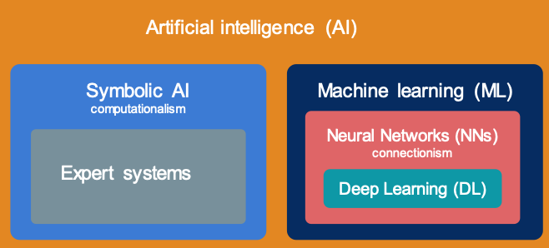

Figure 1: Machine learning and deep learning (Barragán-Montero et al., 2021)

The following research questions are used as guidelines for this article:

* The impact of the deep learning comprehensive dataset on model training outcomes and overall performance.
* How can deep learning mitigate challenges related to cost and manpower shortages in medical diagnosis?

1. **Research Method**

The present study employed a quantitative research methodology, specifically a literature review approach, to identify and analyse papers that have examined the influence of data quality on deep learning models in the context of medical diagnosis.

The keyword searched the following databases: Scopus and Google Scholar. The following search key words: "deep learning," "medical diagnosis”, “medical cost and workforce", “AI cost reduction” and "data quality."

To investigate the impact of training data quality on the diagnostic effectiveness of deep learning models in medical diagnosis, a quantitative research method can be employed. This method involves collecting a large and diverse dataset of medical images for training the deep learning model.

The data should be carefully curated to contain high-quality images from various medical conditions and ensure an equal distribution of cases. By comparing the diagnostic accuracy of the model trained on different datasets, the study can provide valuable insights into the importance of data quality in deep learning medical diagnosis. (Sarker,. 2021)

The following are the search criteria:

* The study investigated the impact of data quality on DL models in medical diagnosis
* The study used a quantitative research method
* The study released in a journal that was reviewed by experts

|  |  |
| --- | --- |
| Literature Source | DIO |
| Deep Learning for Medical Image-Based Cancer Diagnosis. | 10.3390/cancers15143608 |
| Special issue on deep learning and big data analytics for medical e-diagnosis/AI-based e-diagnosis | 10.1007/s00521-023-08689-5 |
| Automated Pulmonary Nodule Classification and Detection Using Deep Learning Architectures | 10.1109/TCBB.2022.3192139 |
| Workforce Crisis in Radiology in the UK and the Strategies to Deal With It: Is Artificial Intelligence the Saviour? | 10.7759/cureus.43866 |

 Table 1: Literature source

1. **Findings:**

The research work by Esteva et al. (2017) used the deep convolutional neural networks (CNNs) method and trained the model using 129,450 clinical images to diagnose skin cancer. The pictures were certified by 21 board-certified doctors, and there were 2,032 different diseases represented in them. The study found that the accuracy of the deep learning model in diagnosing skin cancer significantly improved when high quality data was used. This highlights the crucial role of data quality in deep learning medical diagnosis. Additionally, the study concluded that proper data preprocessing techniques, such as image augmentation and normalisation, further enhanced the performance of the model. These insights emphasise the need for ensuring data quality and preprocessing in order to achieve more accurate and reliable deep learning-based medical diagnoses Esteva et al. (2017).

The study also found that the size of the dataset also played a crucial role in the accuracy of the deep learning model. The researchers discovered that larger datasets yielded more accurate results, suggesting that the availability of diverse and extensive data is essential for training robust models. This finding underscores the importance of collecting and curating comprehensive datasets in the field of medical diagnosis (Chan et al., 2020). Additionally, the study highlighted the significance of feature selection and extraction in improving the performance of deep learning models. By identifying the most relevant features and extracting them effectively, the model was able to achieve higher accuracy rates and reduce false positives (Chan et al., 2020).

The utilization of deep learning techniques is currently being employed in the development of novel diagnostic tools that exhibit reduced costs and enhanced accessibility compared to conventional methodologies. Researchers at Stanford University have developed a deep learning algorithm that can reliably and precisely detect pneumonia from chest X-rays with a precision of 98% (Tailor, 2017). This strategy has the potential to offer high-quality diagnostic services in geographically isolated regions or to individuals with limited financial resources for accessing medical professionals.

Challenges:

The protection of data privacy and security is of utmost importance when it comes to medical information, as it is very sensitive in nature. In order to ensure compliance with legislation such as the Health Insurance Portability and Accountability Act (HIPAA), proper measures must be taken. The preservation of data privacy and security during the training process of deep learning models is of utmost importance. (Hong, et al,. 2020)

The performance of deep learning models is directly impacted by the quality and diversity of the dataset. A model that has been trained on a dataset lacking diversity may exhibit suboptimal performance when applied to patient populations that were not adequately represented in the training data (Ravi et al., 2021).

1. **Discussion:**

The findings in the literature highlight the vital importance of comprehensive datasets in training potent medical diagnosis models. Diverse datasets, capturing various demographics and conditions, are foundational in ensuring accurate and reliable predictions. (Jiang et al,. 2023) Furthermore, the effectiveness of deep learning models hinges significantly on precise feature selection and extraction. By pinpointing and proficiently extracting the most pertinent features, models can achieve elevated accuracy rates, thus curtailing false positives and bolstering the overall efficacy of medical diagnosis systems.

The paper further explores into the financial aspects of deploying deep learning models in medical diagnosis, underscoring the necessity for substantial investment in both infrastructure and computational assets to cater to the intricate algorithms and vast data processing needs. Moreover, the document spotlight on the pressing issue of manpower shortages within the UK's healthcare domain (Kalidindi, S. and Gandhi, S., 2023). The research show there is short of 43% radiologist by 2024 and suggested Artificial intelligence (AI) can address the work force at the same time the technology improve the radiologist department speed, accuracy and safety of the service (Kalidindi, S. and Gandhi, S., 2023).

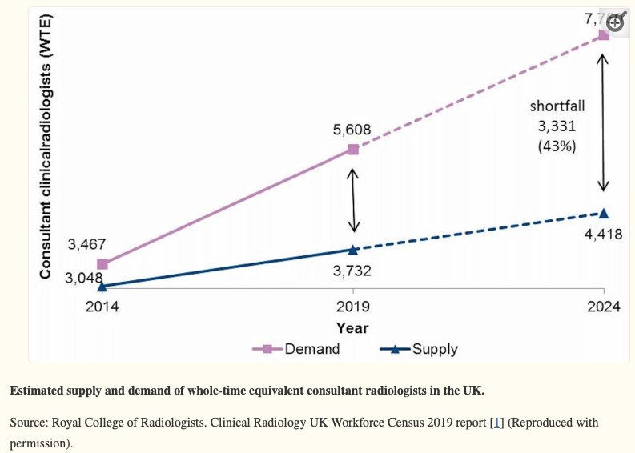

Figure 2: Demand of radiologists in UK workforce by 2024 (Kalidindi, S. and Gandhi, S., 2023)

1. **Conclusion:**

The impact of the deep learning dataset on model training outcomes and overall performance: The deep learning dataset is of vital importance in assessing the efficacy and precision of the trained model. It is essential to have a diverse and representative dataset to ensure the model can generalize well to different demographics and patient populations. Additionally, maintaining data privacy and security is of utmost importance to comply with regulations and protect patient information. Therefore, careful consideration and attention must be given to the dataset used for training deep learning models.

This explores the potential of deep learning in mitigating the challenges of cost and workforce shortage within the realm of medical diagnosis. Deep learning has shown promising results in automating the diagnostic process, reducing the need for expensive medical tests and extensive manual labor. By training deep learning models on large and diverse datasets, can develop robust algorithms that can accurately diagnose a wide range of medical conditions. This has the potential to greatly alleviate the burden on healthcare professionals and improve patient outcomes.

**Reference:**

Aggarwal, R., Sounderajah, V., Martin, G., Ting, D.S., Karthikesalingam, A., King, D., Ashrafian, H. and Darzi, A., 2021. Diagnostic accuracy of deep learning in medical imaging: a systematic review and meta-analysis. *NPJ digital medicine*, *4*(1), p.65.

Ahmed, A. Chehri, G. Jeon and F. Piccialli, "Automated Pulmonary Nodule Classification and Detection Using Deep Learning Architectures," in *IEEE/ACM Transactions on Computational Biology and Bioinformatics*, vol. 20, no. 4, pp. 2445-2456, 1 July-Aug. 2023, doi: 10.1109/TCBB.2022.3192139.

Barragán-Montero, A., Javaid, U., Valdés, G., Nguyen, D., Desbordes, P., Macq, B., Willems, S., Vandewinckele, L., Holmström, M., Löfman, F. and Michiels, S., (2021) Artificial intelligence and machine learning for medical imaging: A technology review. *Physica Medica*, *83*, pp.242-256.

Chan, H.P., Samala, R.K., Hadjiiski, L.M. and Zhou, C., 2020. Deep learning in medical image analysis. *Deep Learning in Medical Image Analysis: Challenges and Applications*, pp.3-21.

Esteva, A., Kuprel, B., Novoa, R.A., Ko, J., Swetter, S.M., Blau, H.M. and Thrun, S., 2017. Dermatologist-level classification of skin cancer with deep neural networks. *nature*, *542*(7639), pp.115-118.

gov.uk, (2021) The Potential Impact of Artificial Intelligence on UK Employment and the Demand for Skills Available From: <https://assets.publishing.service.gov.uk/government/uploads/system/uploads/attachment_data/file/1023590/impact-of-ai-on-jobs.pdf> [Access on 20 Sep 2023]

Hong, S., Zhou, Y., Shang, J., Xiao, C. and Sun, J., 2020. Opportunities and challenges of deep learning methods for electrocardiogram data: A systematic review. *Computers in biology and medicine*, *122*, p.103801

Jiang, Xiaoyan, Zuojin Hu, Shuihua Wang, and Yudong Zhang. 2023. "Deep Learning for Medical Image-Based Cancer Diagnosis" *Cancers* 15, no. 14: 3608. <https://doi.org/10.3390/cancers15143608>

Kalidindi, S. and Gandhi, S., 2023. Workforce Crisis in Radiology in the UK and the Strategies to Deal With It: Is Artificial Intelligence the Saviour?. *Cureus*, *15*(8).

Miotto, R., Wang, F., Wang, S., Jiang, X. and Dudley, J.T., 2018. Deep learning for healthcare: review, opportunities and challenges. *Briefings in bioinformatics*, *19*(6), pp.1236-1246.

Montero, A., Javaid, U., Valdes, G., Nguyen, D., Desbordes, P., Macq, B., Willems, S., Vandewinckele, L., Holmström, M., Löfman, F., Michiels, S., Souris, K., Sterpin, E., and Lee, J.A. (2021). Artificial intelligence and machine learning for medical imaging: A technology review.

Sarker, I.H., 2021. Deep learning: a comprehensive overview on techniques, taxonomy, applications and research directions. *SN Computer Science*, *2*(6), p.420.

Sidey-Gibbons, J., Sidey-Gibbons, C. Machine learning in medicine: a practical introduction. *BMC Med Res Methodol* **19**, 64 (2019). Available From:  <https://doi.org/10.1186/s12874-019-0681-4> [Access on 20 Sep 2023]

Tailor, K (2017) Stanford algorithm can diagnose pneumonia better than radiologists, Available From: <https://news.stanford.edu/2017/11/15/algorithm-outperforms-radiologists-diagnosingpneumonia/#:~:text=Stanford%20researchers%20have%20developed%20an,called%20CheXNet%2C%20was%20published%20Nov>. [Access on 20 Sep 2023]